Greeley Watering Schedule

Watering Restrictions
April 15 through October 31
There is no lawn watering without a variance between November 1 and April 15.
Single Family Customer on the Water Budget
May water any day of the week
Non-Water Budget and Voluntary Residential Watering Schedule
Even addresses: Sunday, Tuesday, Thursday
Odd addresses: Monday, Wednesday, Saturday
Commercial, Institutional, Industrial, Businesses, Churches, Non-profits, Multifamily, HOAs etc.
Tuesday, Friday, Sunday

No Watering Between 10 a.m. and 6 p.m.
- New lawn variances are available with proper soil amendment (4 cubic yards per 1,000 square feet of lawn). A variance will increase your water budget for a period of time to properly water the lawn. Apply online and upload receipts for new sod or seed, compost installation, and proof of rototilling (photos, rental receipt or lawn service invoice). Go to Greeleygov.com/conserve to apply.

- Trees, shrubs, flower and vegetable gardens may be watered at any time by drip irrigation, low volume, bubblers, sprinkler, restrictive hose nozzle, watering can, by weeping-type soaker hoses or by a hose-end sprinkler. Water trees and shrubs during prolonged dry periods to keep trees healthy.

- Hosing paved surfaces, including decks, driveways, patios, sidewalks, vinyl siding, roof gutters, windows, and garages is allowed with minimal runoff. Excessive water flows into the gutters and leaving your property is considered a waste and could result in a violation.

- Home car washing is allowed with a restrictive nozzle hose and bucket, and minimal runoff.

- Any person who violates the restrictions during a calendar year will be fined $100 for the first offense, $250 for the second, $500 for the third, and for the fourth and subsequent violations $500 and the cost of installing a flow restrictor to limit outdoor water use. Violations on non-residential property will receive fines that are double those described above.

Cycle and Soak
This method of watering is very effective to water your lawns and eliminate runoff. If you have a sprinkler clock that has multiple start times, take advantage of it and try the cycle and soak method.
Most spray heads disseminate 1.5-2 inches of water per hour.
Most rotor sprinklers disseminate approximately .3-.5 inches of water per hour.

Sprinkler Type | Run Time Needed | 2-cycle # of minutes each | 3-Cycles # of minutes each | Time between cycles
Spray Heads | 15 | 7 | 5-6 | 45-60 min
Rotors | 45 | 22 | 13-14 | 45-60 min
Original Schedule | 4a.m.
Zone 1 (Sprays) north side shady | 13
Zone 2 (sprays) south side hot | 15
Zone 3 (rotors) east side morning sun | 40
Zone 4 (rotors) west afternoon sun | 45
Total Runtime | 113
New Cycle and Soak (2 cycles) | 4 a.m. | 5 a.m.
Zone 1 (Sprays) north side shady | 6 | 6
Zone 2 (sprays) south side hot | 7 | 7
Zone 3 (rotors) east side morning sun | 20 | 20
Zone 4 (rotors) west afternoon sun | 20 | 22
Total Runtime | 53 | 55 | 108
New Cycle and Soak (3 cycles) | 4 a.m. | 5 a.m. | 6 a.m.
Zone 1 (Sprays) north side shady | 5 | 5 | 5
Zone 2 (sprays) south side hot | 4 | 5 | 5
Zone 3 (rotors) east side morning sun | 12 | 13 | 13
Zone 4 (rotors) west afternoon sun | 13 | 13 | 13
Total Runtime | 34 | 36 | 36 | 106

Cycle and Soak Example
- For example, instead of running your sprinklers for one long run time, divide it into 2 or 3 shorter cycles and you may find that you can cut down your total minutes’ run.
- Make sure that you have a non-watering period of 45-60 minutes in between cycles. It is important not to have it go more than 60 minutes between cycles. The first cycle wets the soil and then the second and third cycle soaks into the root zone.
- We have seen people splitting the cycle between day and evening and that is NOT effective.
- For a personalized watering schedule, call for a FREE sprinkler system audit call 970-350-9811 or sign up online GreeleyGov.com/Audits

Adjust Run Times Monthly

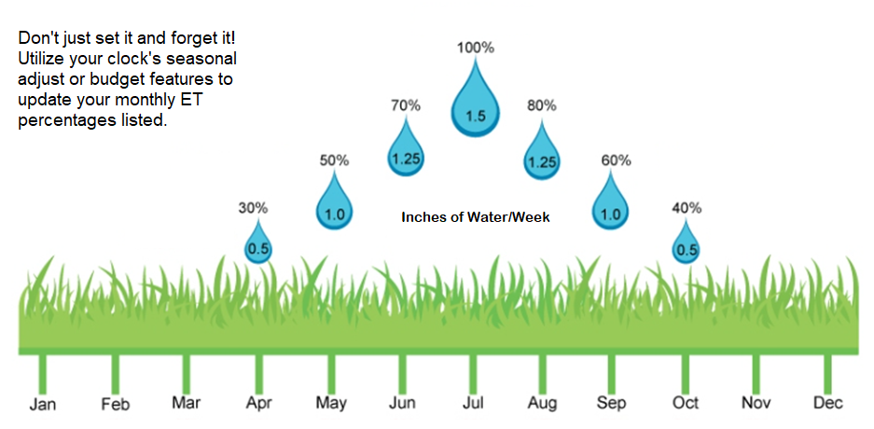

It is best practice to change your sprinkler program each month to match the weather, and water needs of your lawn. Ideally, lawn watering over a season should follow a bell curve pattern with water use peaking in July. Many people are good at ramping up their lawn watering but forget to turn it down once temperatures start to decrease. Although temperatures might stay high in September it is hotter for a shorter period and therefore less water is needed.

